MODULE 2 – Introduction to Technology Of EV

2.2 Types of Electric Vehicles

Practice Problems

### Question 1 Please have a look at the image below. Image courtesy: Fred the Oyster, licensed CC-BY-SA.

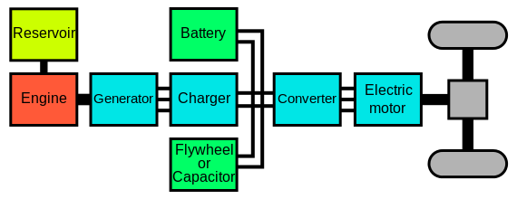

Question: What is the hybrid vehicle drivetrain type shown in the picture?

1. Parallel hybrid
2. Plug-in Series hybrid
3. Series-parallel hybrid
4. Series hybrid

Ans. D

### Question 2a Let's go back to the tool we used in module 1 to find the fuel economy of the most popular gasoline and plug-in electric car in the USA in 2016, the Honda Civic and the Chevrolet Volt. Open the tool via [this link](http://www.fueleconomy.gov/feg/Find.do?action=sbsSelect). Use the compare tool to compare the ‘2017 Honda Civic 4Dr, 2.0 L, 4 cyl, Automatic’ and the ‘2017 Chevrolet Volt 1.5 L, 4 cyl, Automatic’.

What is the MPGe and MPG of the Volt and the MPG of the Civic? Use the ‘Fuel economy’ tab on the top and compare the ‘EPA Fuel Economy’

1. The MPGe and MPG for the Volt are resp. 42 and 106, The Civic has an MPG of 34
2. The MPGe and MPG for the Volt are resp. 106 and 42, The Civic has an MPG of 34
3. The MPGe and MPG for the Volt are resp. 106 and 34, The Civic has an MPG of 42

Ans. B

### Question 2b By what factor is the hybrid car more efficient than the gasoline car based on combined city/highway usage, when powered by the batteries and when powered by the engine?

1. 3.1x when on battery, 1.23 times when on engine
2. 1.23x when on battery, 3.1 times when on engine
3. 3.1x when on battery, 2.1 times when on engine

Ans. A

### Question 2c What is the electric range of the Volt?

1. 33 miles
2. 43 miles
3. 53 miles

Ans. C

### Question 2d Do the cars have a similar total range with a ‘full tank’ of electricity and gasoline?

1. No, the Volt has a larger range than the Civic with a 'full tank'
2. No, the Civic has a larger range than the Volt with a 'full tank'
3. Yes, the cars have a similar range with a 'full tank'

Ans. C